**sequence diagram for web page:**

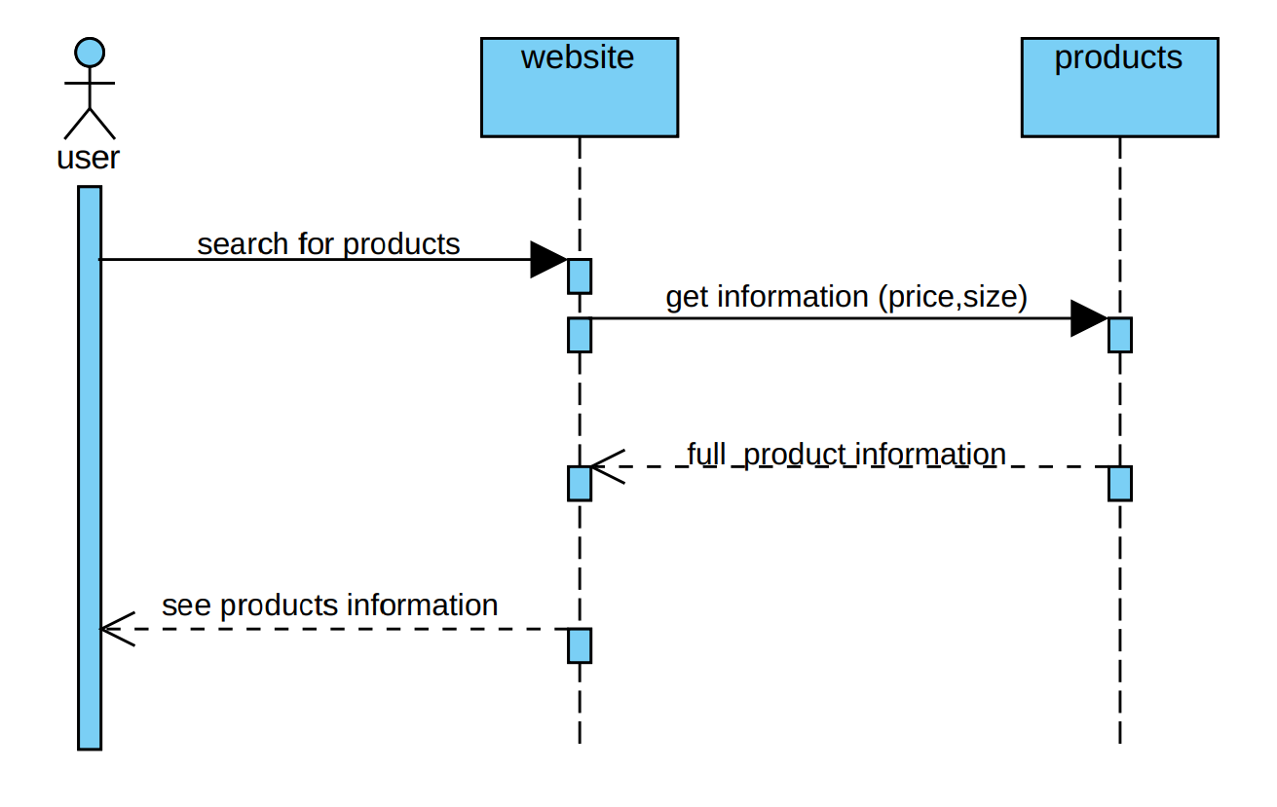

**sequence diagram for the cart:**

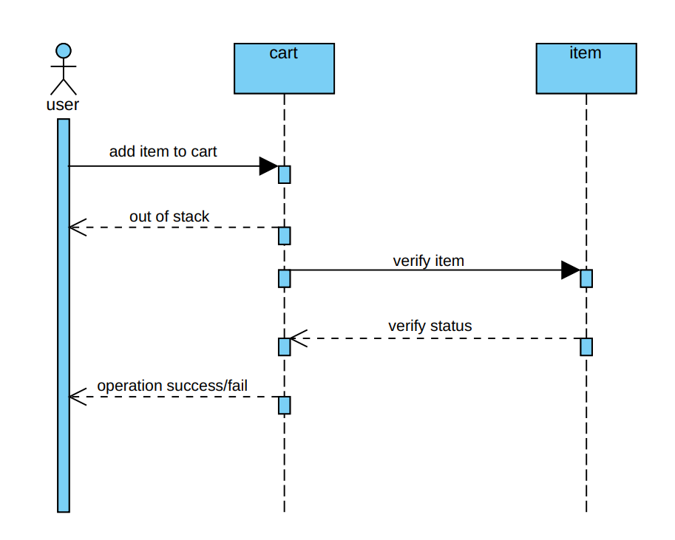

**sequence diagram for the full process:**

